Quest 5.
Given the array A = [-1, 3; 4, 2], raise A to second power by array exponentiation (same as element-by-element). Raise A to second power by matrix exponentiation. Explain why the answers are different.
Raising A to the second power by array exponentiation.
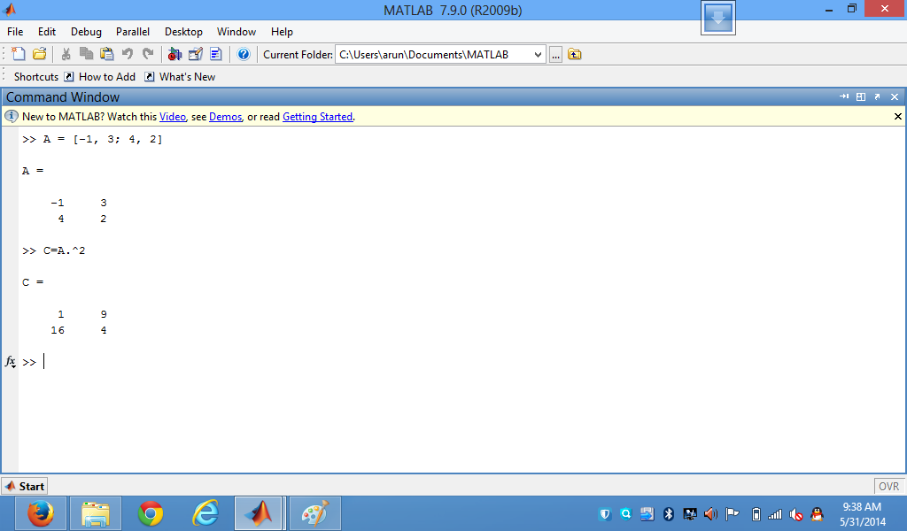
Raising A to the second power by matrix exponentiation
It calculates the square of the individual array elements.

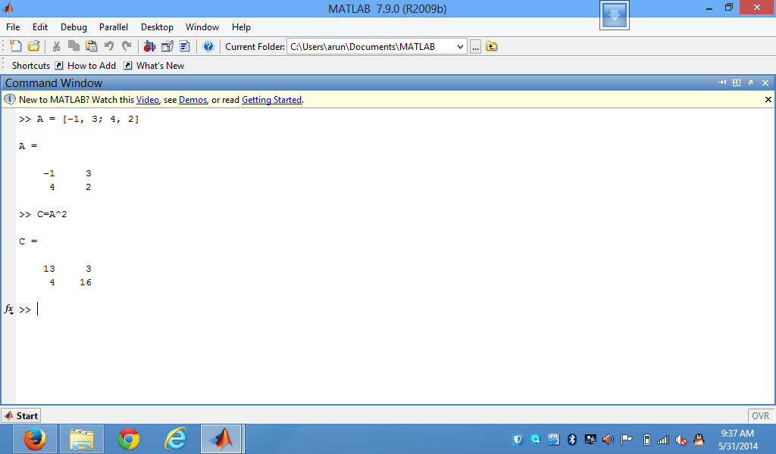
It calculates the square of the matrix by normal matrix multiplication
The solution varies since matrix exponentiation is an entirely procedure that takes the exponent of each element of the matrix.
For instance, when you write
matrix_exp = A^2;
It calculates the square of the matrix by normal matrix multiplication i.e. A*A. This is matrix exponentiation.
Again, when you write
elem_exp = A.^2;
it finds the square of the individual array elements. It basically computes the inner product, considering the rows of A as individual vectors. This is element-by-element.

